**Game Homepage Instructions**

1. In the login interface, enter any email account and send the verification code.

2. Enter the verification code number as "1111"

3. Check "I agree to ArcX Terms of use and Privacy Palicy"

4. Click “Login/sign up”

**Here are some premium accounts for testing.**

Email:Colosseum3@arcx.com

Email:Colosseum4@arcx.com

Email:Colosseum5@arcx.com

Click "send" to get the verification code and enter "1111"

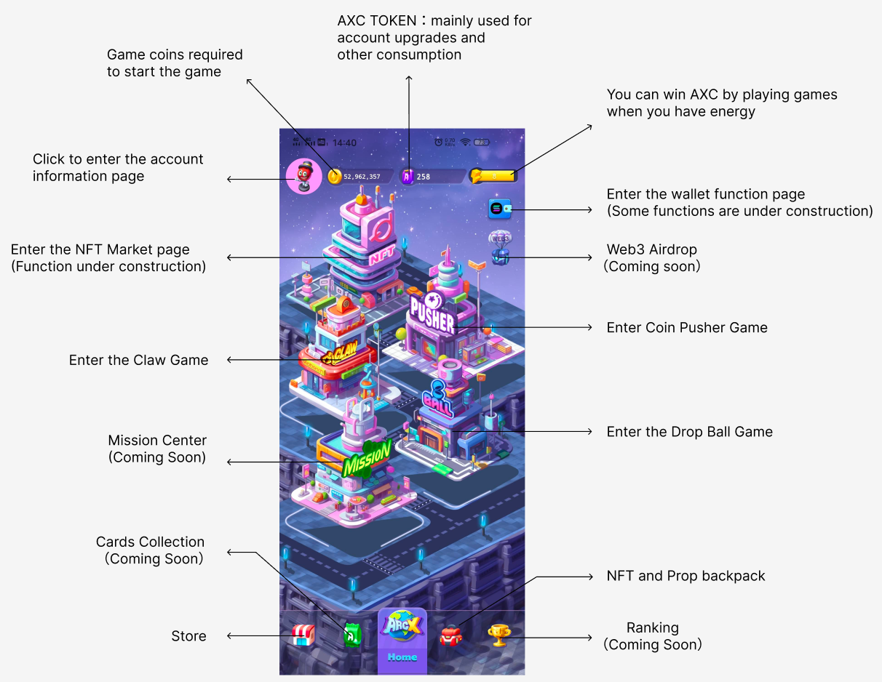

**Coin Pusher Game Instructions**

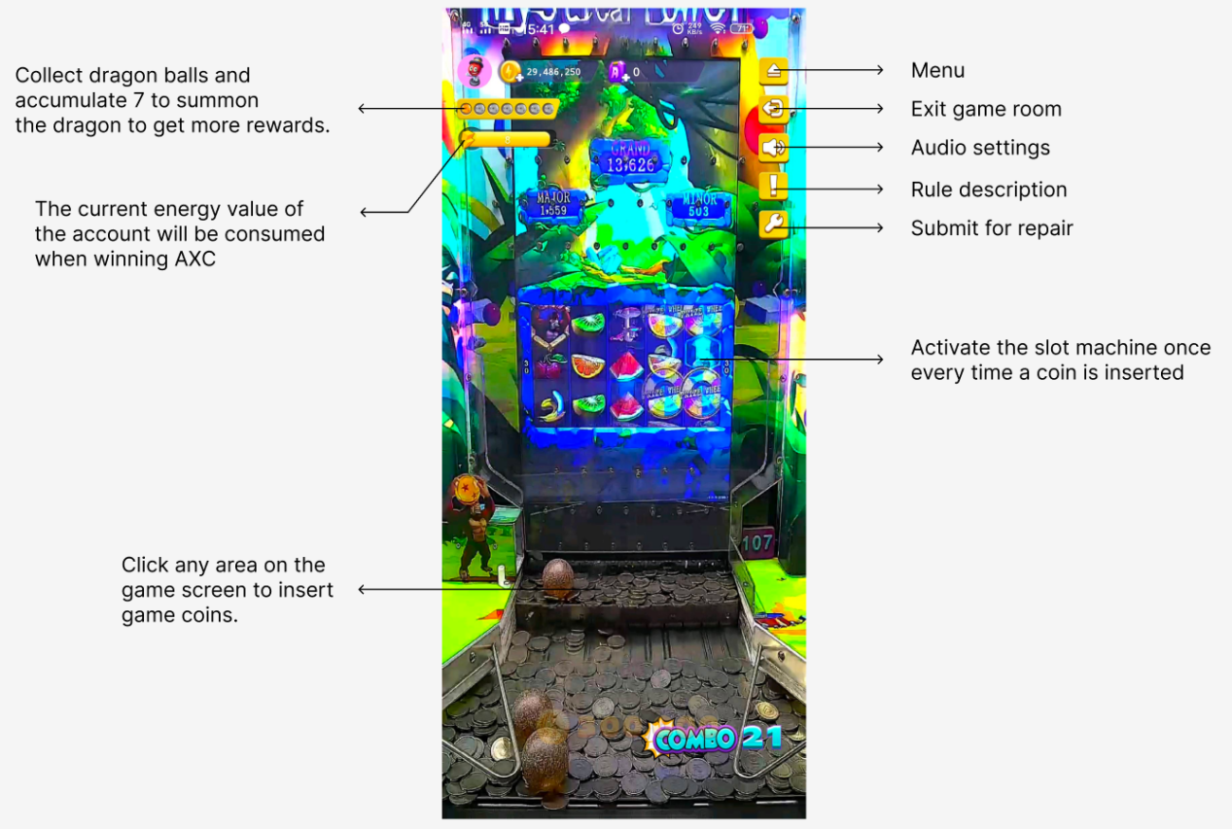

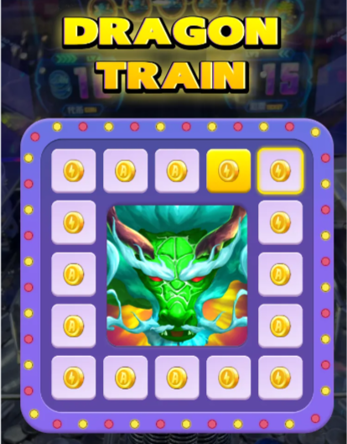

**Claw Game Instructions**

Click "PLAY" to start the machine.

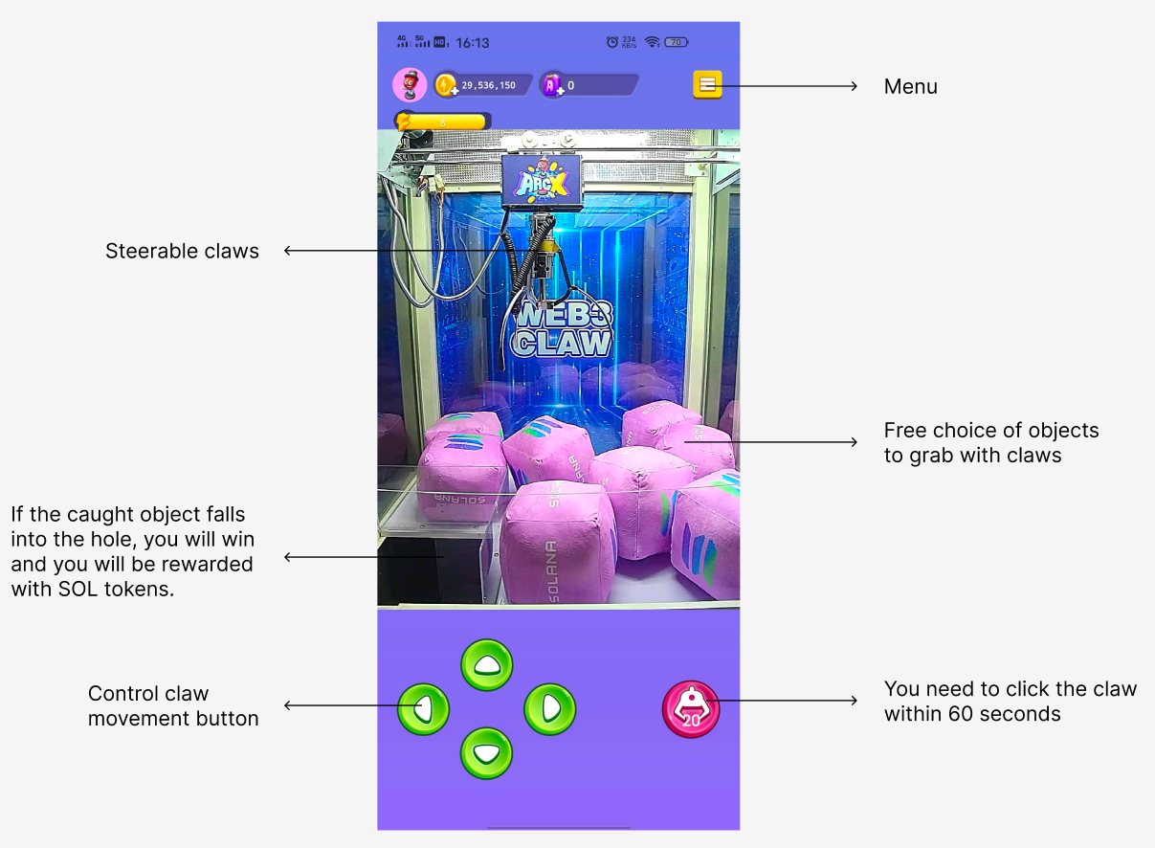

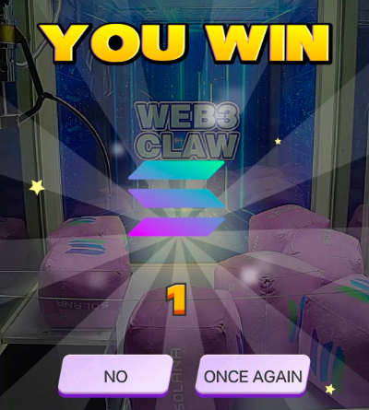

**Ball Dropping machine Instructions**

Click "PLAY" to start the machine.

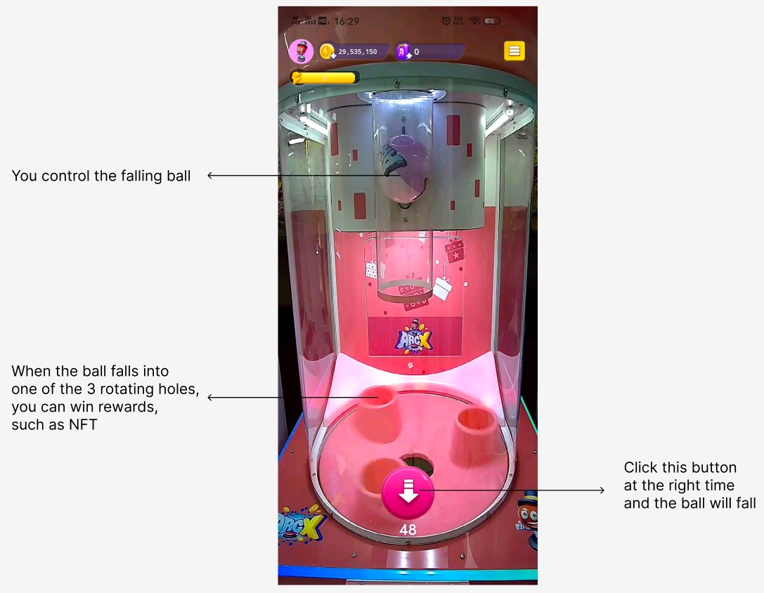

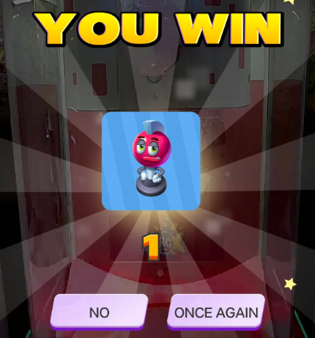

**Wallet Instructions**

Click the wallet button from the homepage to enter.

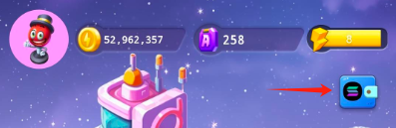

Wallet

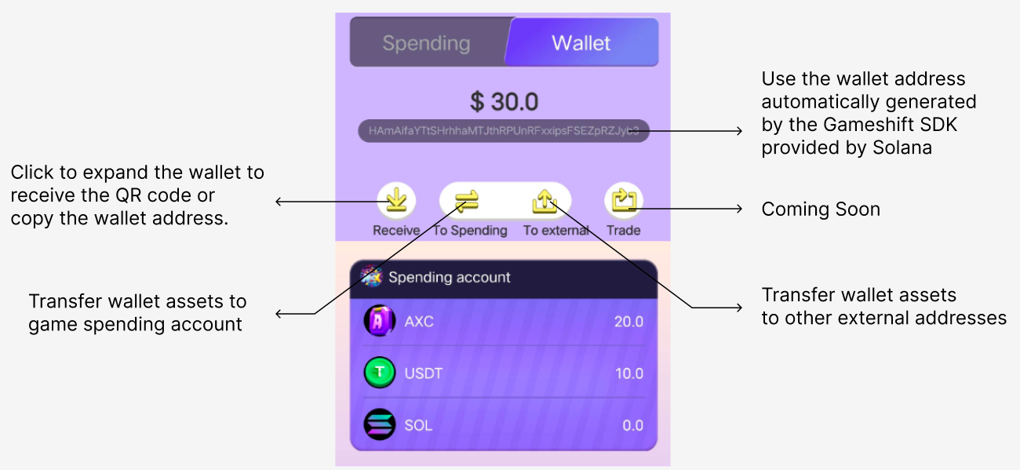

Click any token button to enter the transfer page

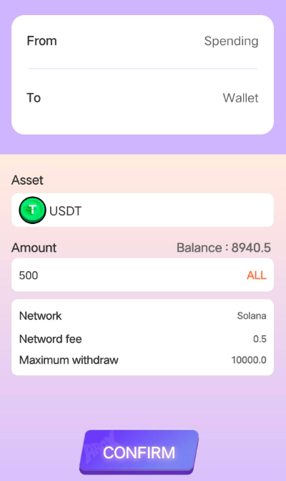

**Account level Function**

Click on the avatar from the homepage to enter.

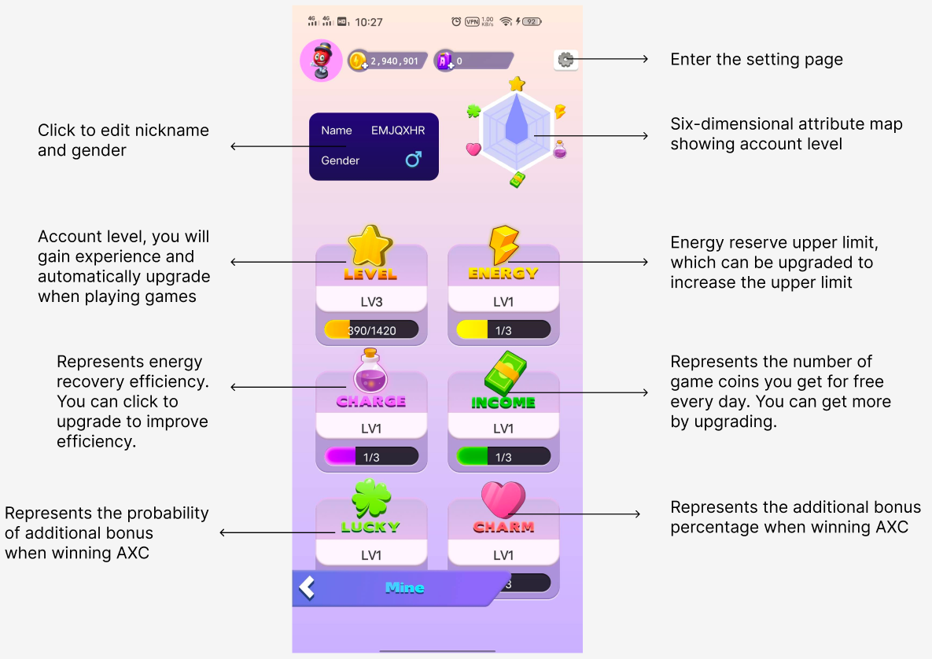

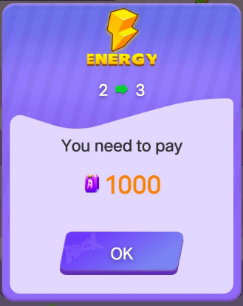

**Other page display**

The following content is under development and may not be fully displayed in the Demo for the time being.

